Architectural Components - Presenter

📝Definition
# Source: AI Source: Provided by: [Data Path: Persons Table -> ID Column: 1, Name_En Column: Motasem Essam] -> From: [ChatGPT] on [1/23/2026]
The Presenter is a component used in the MVP (Model-View-Presenter) pattern. It acts as the middle layer between the View and the Model, handling presentation logic and orchestrating data flow.
👉 Think of the Presenter as a smart manager: it retrieves data from the Model, formats it, and instructs the View what to display.

🔑 Responsibilities of Presenter
# Source: AI Source: Provided by: [Data Path: Persons Table -> ID Column: 1, Name_En Column: Motasem Essam] -> From: [ChatGPT] on [1/23/2026]
- Fetch and process data from the Model
- Apply presentation logic (formatting, filtering, etc.)
- Update the View with prepared data
- Handle user input forwarded by the View
- Keep View passive, containing no business logic

🧱 Example (MVP)

Model
# Source: AI Source: Provided by: [Data Path: Persons Table -> ID Column: 1, Name_En Column: Motasem Essam] -> From: [ChatGPT] on [1/23/2026]
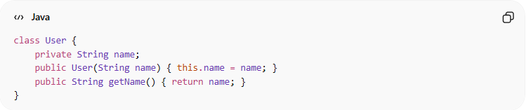
class User {
private String name;
public User(String name) { this.name = name; }
public String getName() { return name; }
}

View Interface
# Source: AI Source: Provided by: [Data Path: Persons Table -> ID Column: 1, Name_En Column: Motasem Essam] -> From: [ChatGPT] on [1/23/2026]
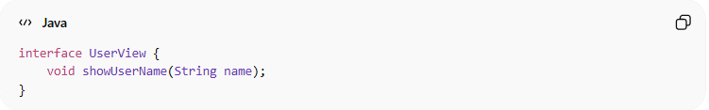
interface UserView {
void showUserName(String name);
}

Presenter
# Source: AI Source: Provided by: [Data Path: Persons Table -> ID Column: 1, Name_En Column: Motasem Essam] -> From: [ChatGPT] on [1/23/2026]
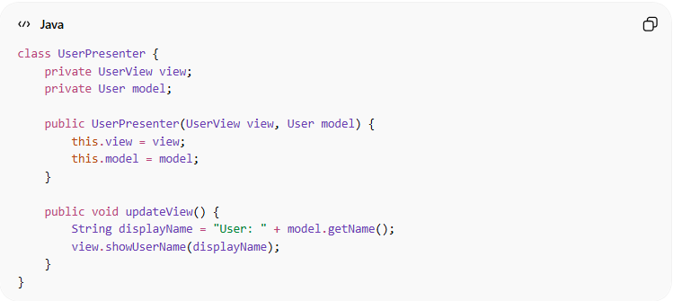
class UserPresenter {
private UserView view;
private User model;

public UserPresenter(UserView view, User model) {
this.view = view;
this.model = model;
}

public void updateView() {
String displayName = "User: " + model.getName();
view.showUserName(displayName);
}
}

❌ Bad Example (No Presenter)
# Source: AI Source: Provided by: [Data Path: Persons Table -> ID Column: 1, Name_En Column: Motasem Essam] -> From: [ChatGPT] on [1/23/2026]
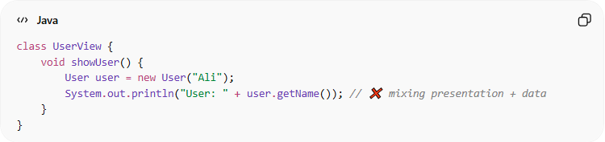
class UserView {
void showUser() {
User user = new User("Ali");
System.out.println("User: " + user.getName()); // ❌ mixing presentation + data
}
}
👉 Problems:
- View directly accesses Model
- Presentation logic is inside View
- Hard to test or reuse

✅ Good Example (With Presenter)
# Source: AI Source: Provided by: [Data Path: Persons Table -> ID Column: 1, Name_En Column: Motasem Essam] -> From: [ChatGPT] on [1/23/2026]
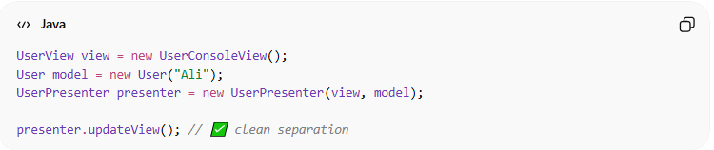
UserView view = new UserConsoleView();
User model = new User("Ali");
UserPresenter presenter = new UserPresenter(view, model);

presenter.updateView(); // ✅ clean separation
👉 Benefits:
- View remains passive
- Presenter handles logic and formatting
- Easy to unit test without UI

🔄 Presenter in Patterns
# Source: AI Source: Provided by: [Data Path: Persons Table -> ID Column: 1, Name_En Column: Motasem Essam] -> From: [ChatGPT] on [1/23/2026]
- MVP → Core component managing View updates
- MVVM → Replaced by ViewModel
- MVC → Controller handles similar role, but Presenter focuses on UI logic

⚠️ Common Mistakes
# Source: AI Source: Provided by: [Data Path: Persons Table -> ID Column: 1, Name_En Column: Motasem Essam] -> From: [ChatGPT] on [1/23/2026]
- Putting business logic in Presenter ❌
- Allowing View to directly modify Model ❌
- Making Presenter too big (mixing many responsibilities) ❌

💡 Key Idea
# Source: AI Source: Provided by: [Data Path: Persons Table -> ID Column: 1, Name_En Column: Motasem Essam] -> From: [ChatGPT] on [1/23/2026]
Presenter decouples the View from the Model, managing UI logic and orchestrating data display.

🧾 Summary
# Source: AI Source: Provided by: [Data Path: Persons Table -> ID Column: 1, Name_En Column: Motasem Essam] -> From: [ChatGPT] on [1/23/2026]
Presenter:
- Mediates between View and Model
- Handles presentation logic
- Keeps View passive
- Improves testability and maintainability

